**Functional Groups**



For each of the following compounds, circle the functional group and name it.

1. Pyruvic acid

2. Alanine

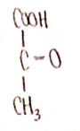 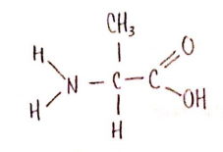

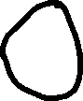

3. Butanal

4. Glycerol

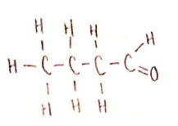 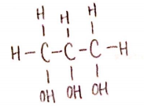

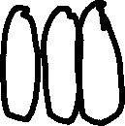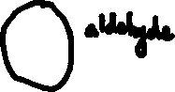

5. 2-Pentanone



6. 3-Amino butanal

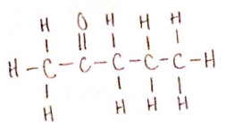 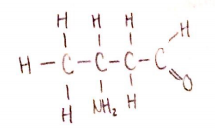

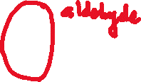

7. Ethoxypropane

8. Methyl propanoate

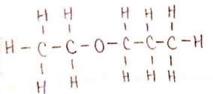 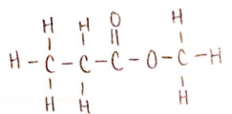

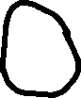

**Biochemistry**



Draw structural formulae for each of the following:



1. 2-amino propanoic acid

2. 2-butanone

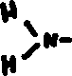

3. 4-methyl pentanal



4. 3-methyl pentanol

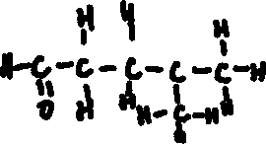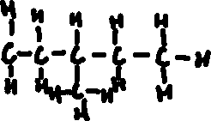

5. 3-amino, 2-pentene

6. 4-amino, 1-pentyne

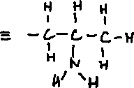

7. butyl propanoate

8. di-ethyl ether

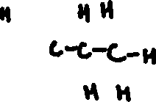

9. 2-amino, 4-methyl pentanoic acid

10. 3-hydroxyl propanal

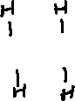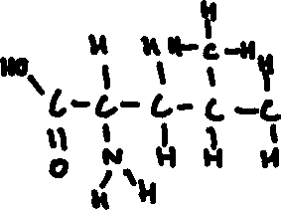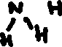

**Biochemistry**



Name and draw structural formulae for each of the following:

1. CH3OH



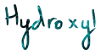



2. CH3 CH(NH2)2



3. CH3 CO CH3

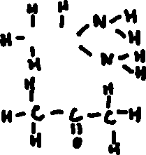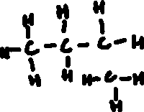

4. (C2H5)(CH3)CH2



5. C2H5 CHO

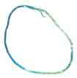

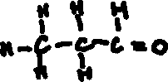

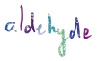

6. C3 H7 COOH

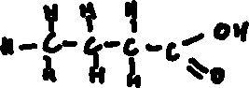

7. (NH2)CH(CH3)(COOH)

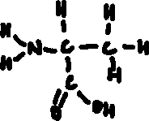

8. C3H9N (draw three isomers)

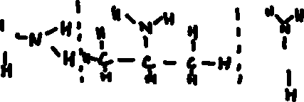

For each structural formulae, circle and identify each functional group.

